**___BAPI________________________________**

**BAPI (Business Application Programming Interface)**

* acts as interface between the SAP and Non- SAP system.

for eg. from R/3 to Java, Visual Basic, Internet Intranet.

* BAPI is RFC enable function module of SAP Business Object which is stored and maintained in **BOR** (Business Object Repository).
* First of all, RFC enabled function module needs to be created in the SE37 transaction and then it should be assigned to the Business Object in SW01 transaction. Only then that Business object can be used as BAPI.
* Parameters in RFC must be Data Dictionary Types.
* Exceptions cannot be added here, instead return value is used **i.e.** BAPI return

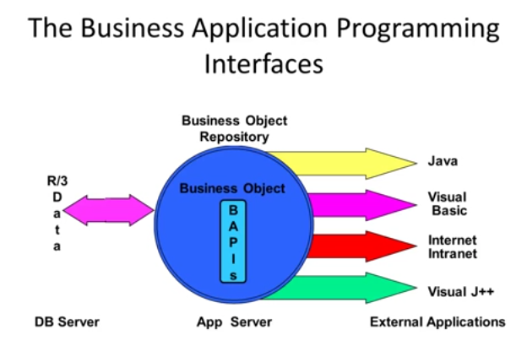

**Difference between RFC and BAPI**

* Every BAPI is an RFC but every RFC is not a BAPI.
* BAPI always have a return table but it may or may not be present in RFC.
* BAPI contains whole functionality like BAPI_PO_CREATE will create a Purchase order

But this whole functionality may or may not be present in RFC.

* You can’t call RFC from Non-SAP system but you can call BAPI from Non-SAP system.
* BAPI is used to transfer the data from SAP to SAP and Non-SAP to SAP but RFC is used to transfer the data from SAP to SAP.

**What is BOR (Business Object Repository)?**

* BAPI is defined as method of SAP objects which carry out specific business function and these methods are stored and maintained by BOR.
* BOR is responsible for any change in BAPI.

**Difference between BAPI and BDC**

**BAPI**

1. BAPI is used to upload the data

from flat file to SAP system

directly.

1. BAPI is faster.
2. BAPI never cause program to

terminate whenever error

occurs.

1. BAPI performs their own

Authorization checks to

Validate the user.

1. In BAPI, the fields in the flat file are not fixed.
2. Whenever the version is changed the code doesn’t need to be changed.

**BDC**

1. BDC uploads the data from a flat file to SAP system through screens.
2. BDC is slower.
3. Sometimes BDC open group, BDC Insert, BDC close group may cause program to terminate.
4. In BDC, we need to provide the authority check to validate the user.
5. In BDC, the fields in the flat files are fixed.
6. Whenever the version is changed, the code is also needs to be changed.

**What is Business Object?**

* Any kind of application document. Like below

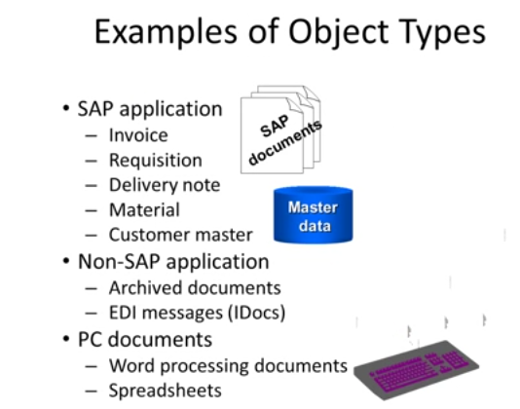

NOTE:

* BAPI must not contain call transaction.
* BAPI must not invoke commit work. Instead of commit work, BAPI calls TRANSACTION_COMMIT function module.